Name: Mrunali Katta

ID: 017516785

Github link:

**Homework 07**

1. Create a dbt project with snowflake connector (1 pt)

* Below is the snapshot of installing dbt-core module via terminal:

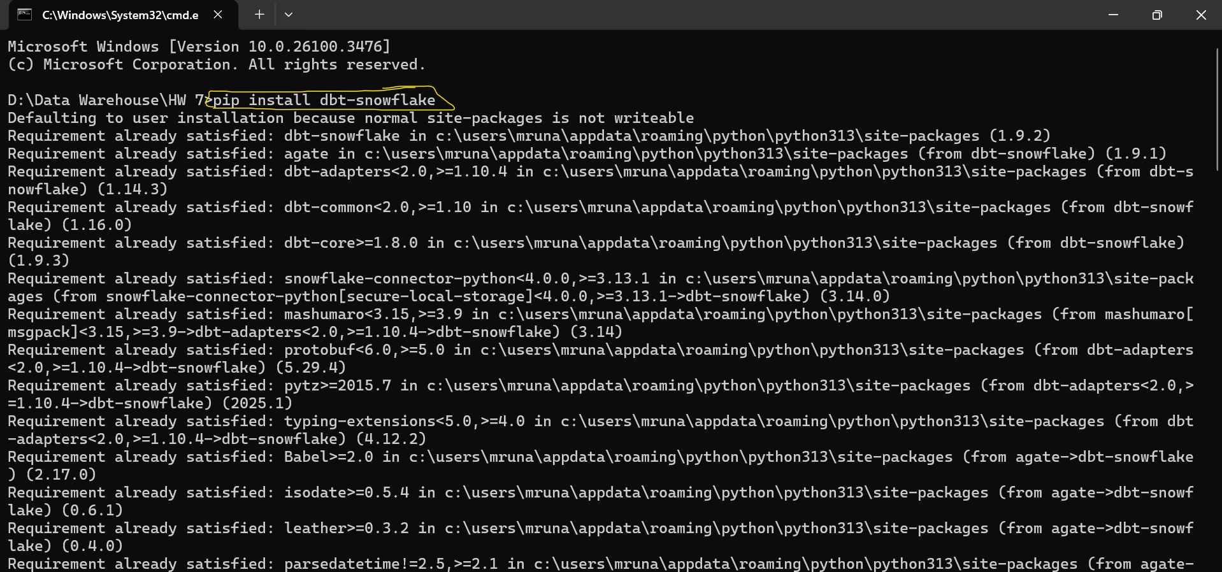

Below is the snapshot of configuring DBT environment and establishing Snowflake connection: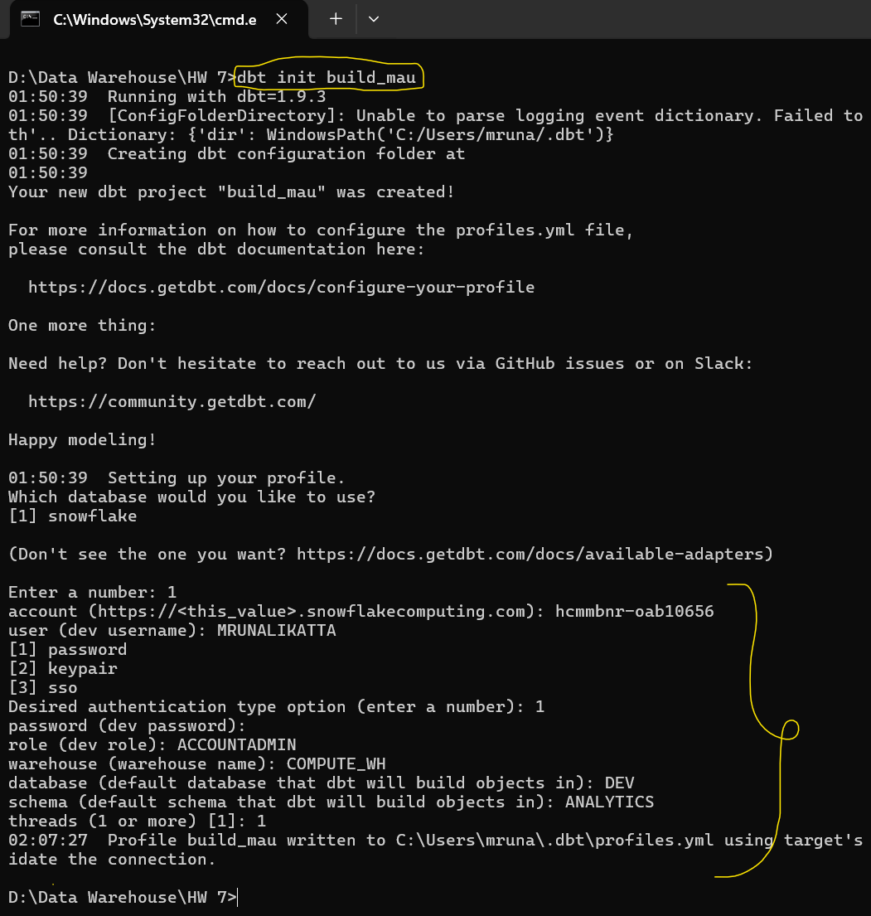

1. Set up Input models (2pt)
   1. Input tables should be built as CTE
   2. Show contents of models/input/user_session_channel.sql and input/session_timestamp.sql

* Below is the snapshot of input/user_session_channel.sql and input/session_timestamp.sql to build input views using CTE (as default materialize is set to view):

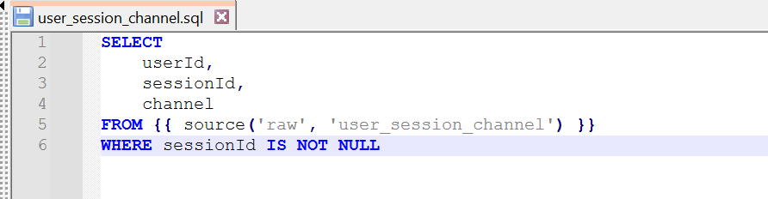

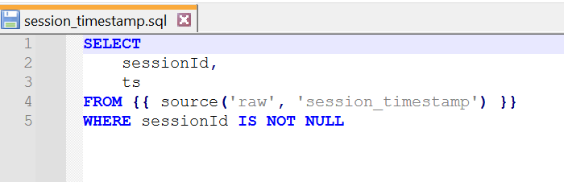

Below is the snapshot of executing the queries and SUCCESS indicates that the view was successfully created:

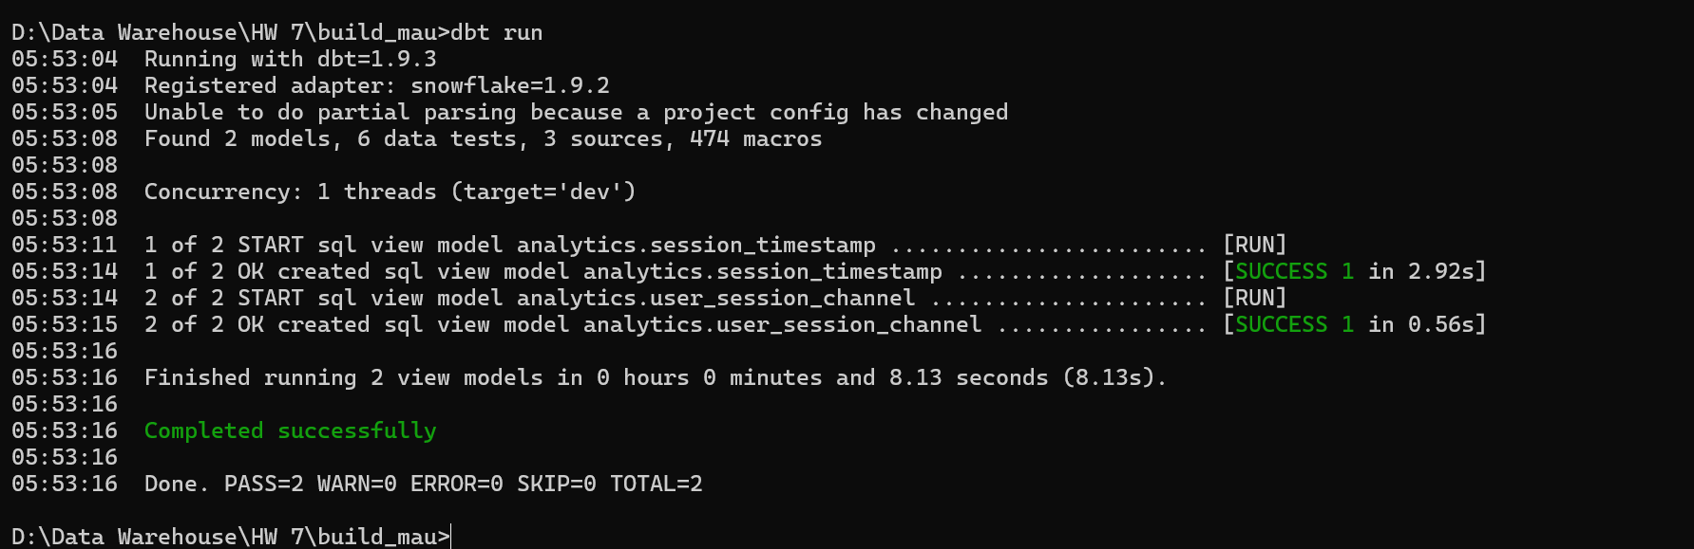

Below is the snapshot of Snowflake indicating that the view was successfully created in the warehouse:

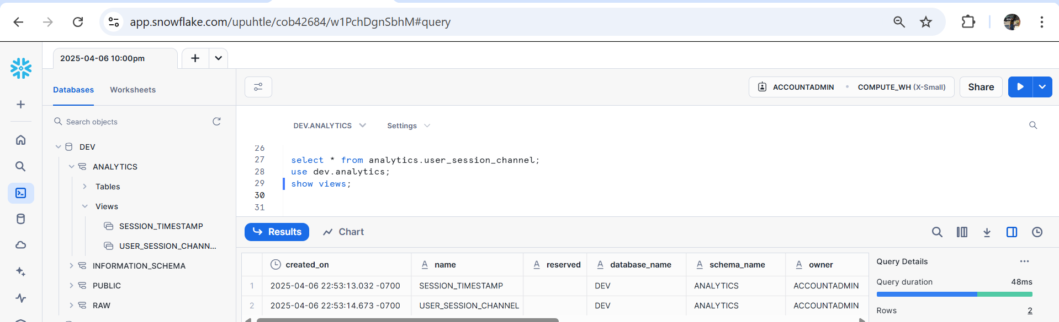

1. Set up Output models (1pt)
   1. Show contents of models/output/session_summary.sql

Below is the snapshot of *models/output/session_summary.sql* to build the output table in *dev.analytics* schema of snowflake:

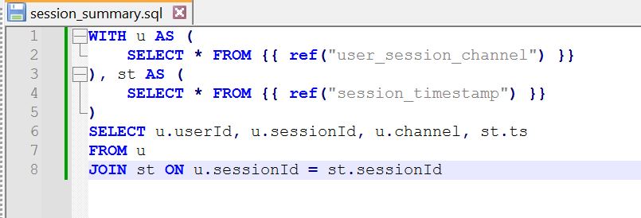

Below is the snapshot of executing the above query from terminal and the SUCCESS message indicates that the table was successfully created using **dbt run**  command

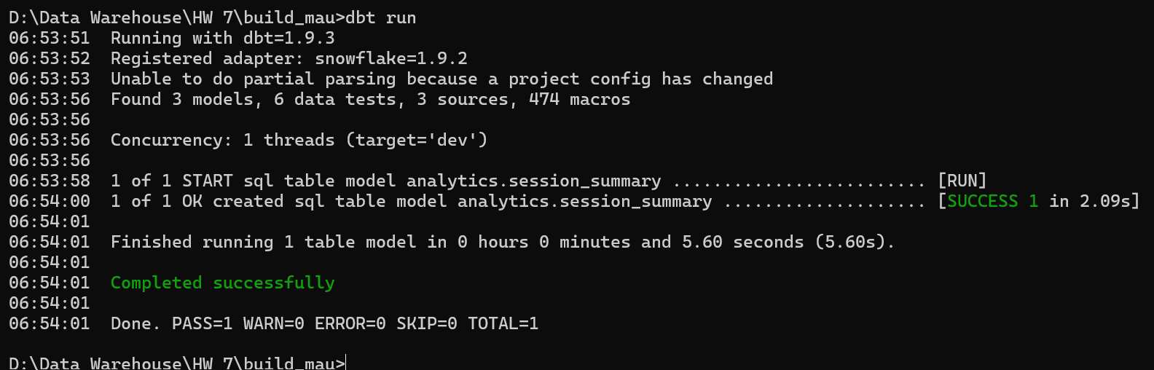

Below is the snapshot of Snowflake indicating that the table was successfully created in the warehouse:

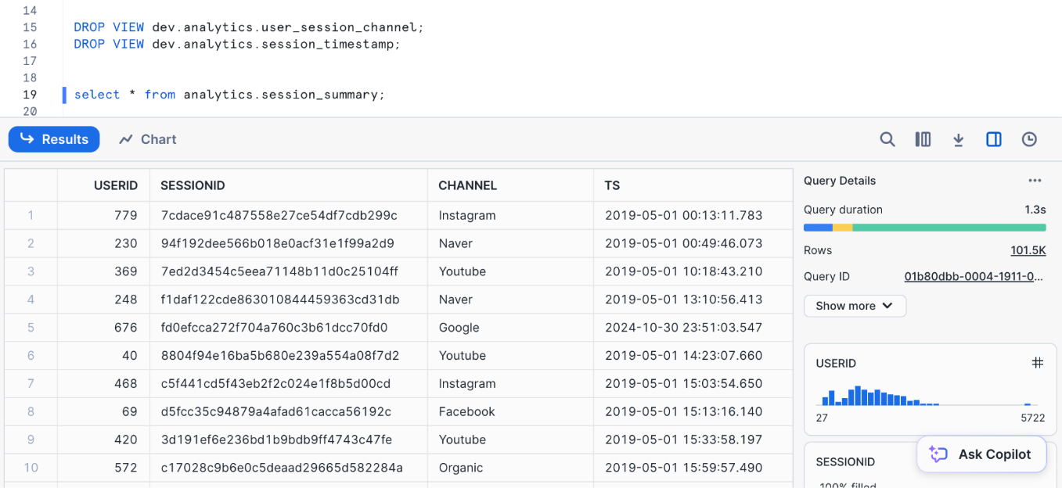

1. Add Snapshot to the output table (session_summary) (2pt)
   1. Show contents of snapshots/snapshot_session_summary.sql

Below is the snapshot of *snapshots/snapshot_session_summary.sql* to build the snapshot table in *dev.snapshot* schema of snowflake:

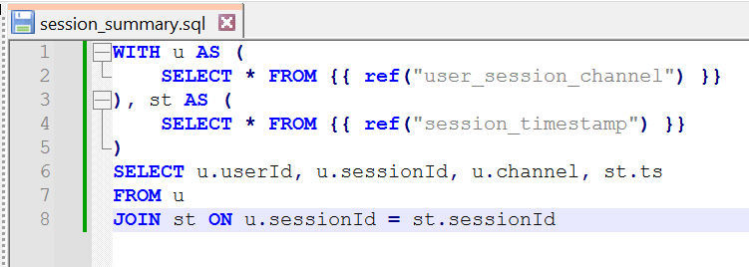

Below is the snapshot of executing the above query from terminal using **dbt snapshot**  command

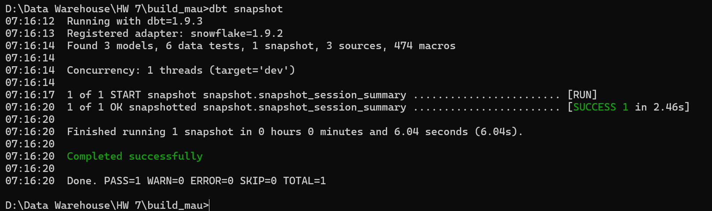

Below is the snapshot of Snowflake indicating that the table was successfully created in the warehouse:

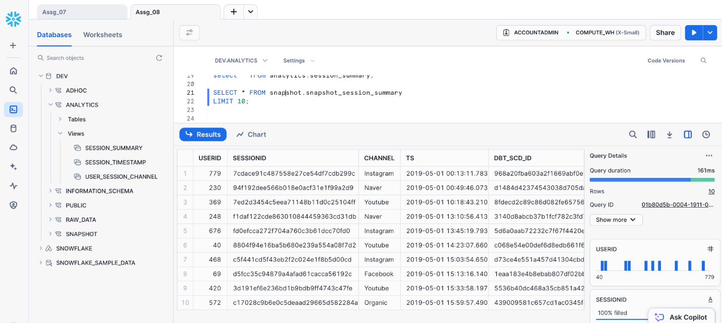

1. Add at least 2 tests to sessionId field of session_summary (2pt)
   1. Show contents of models/schema.yml

After creating the above table, I intend to identify the type of snapshot for which I have performed the following:

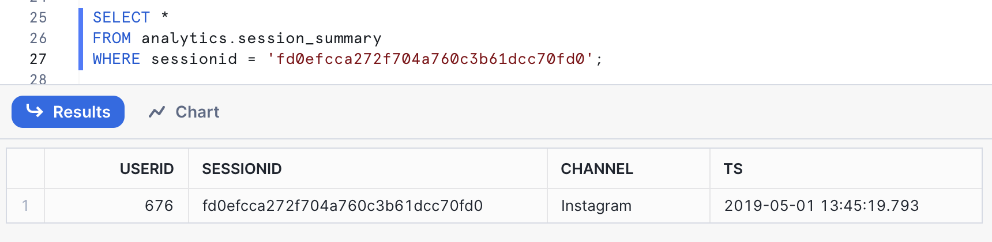

Below is the snapshot of updating records against one of the sessionId - 'fd0efcca272f704a760c3b61dcc70fd0' using the **UPDATE** query in sql:

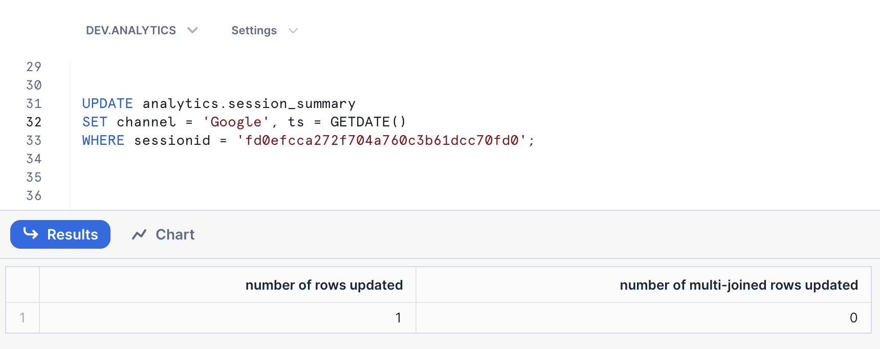

As shown in figure below, a new row is added to track the change history for the sessionId - 'fd0efcca272f704a760c3b61dcc70fd0' where top row has updated *channel* value and *dbt_valid_to*. Hence, this is of **SCD (Slowly Changing Dimension) Type 2.**

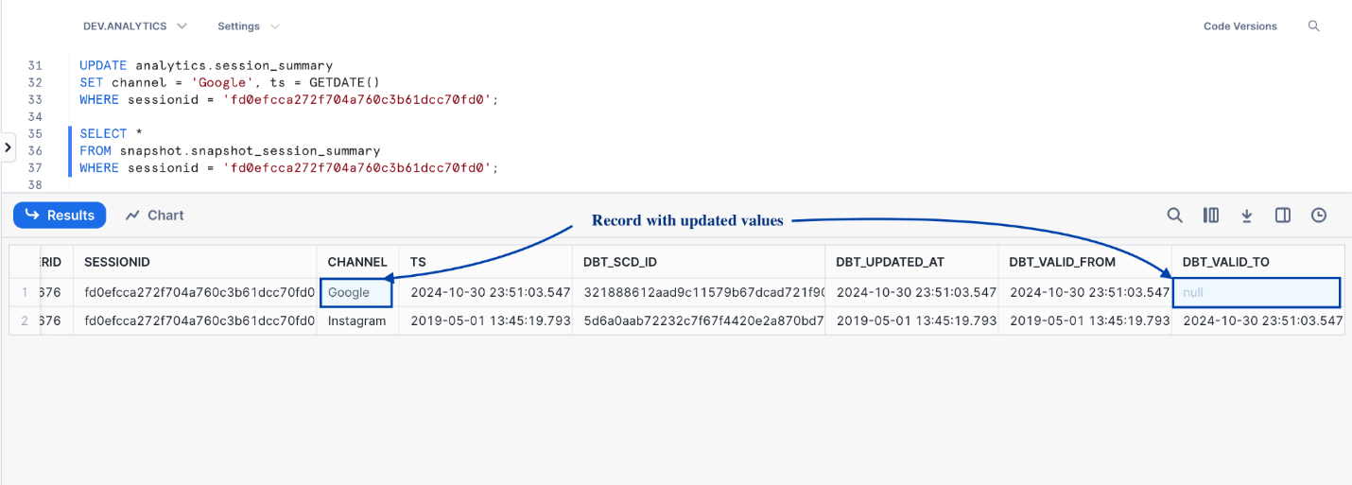

To perform the tests, I have used the below query:

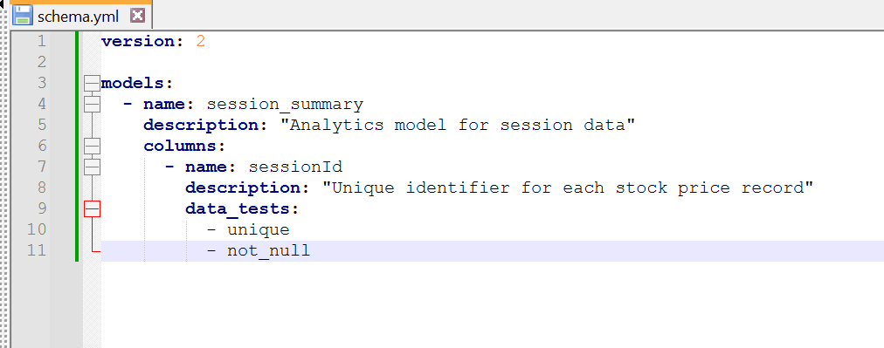

Below is the snapshot of running **dbt test** command to perform two checks - **unique** and **not_null** and as shown, both tests have passed:

